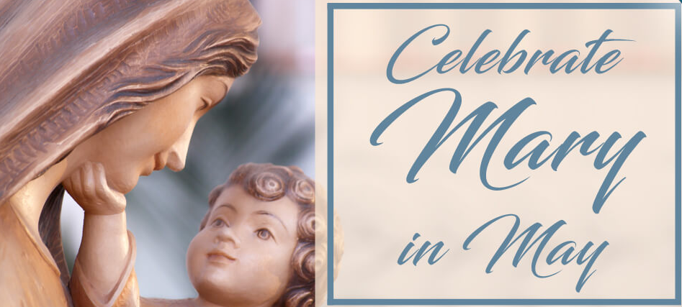
Mary

Reflections, Activities & Faith Sharing for Young People

The Story of Mary
Reflect on each of the moments shared in the story of Mary. Mary’s life and example offers us an opportunity to learn about her response to God.
After reading each moment, reflect on the following questions:
- What does Mary teach me about hope and love?
- How does Mary’s live invite me to strengthen my relationship with God?
- What is something I can do today to respond to God’s call?
Source: https://s3.us-east-1.amazonaws.com/lpress-craft/files/ocf-files/mary-intergen-files/the-story-of-mary.pdf

Praying with Scripture: Learning to Say Yes
Jesus was born because a very special woman said yes when God asked her to be the mother of the Savior. Let us look at the Scripture passage that tells the account of Mary's yes to God.
Read the Annunciation from the Gospel of Luke 1:26-38. You can invite those that live with you to join you in this reflection and take turns reading the different parts of the scripture. One can be the narrator, someone can be the angel Gabriel, and another can be Mary.

After you read the scripture, break open the experience by reflecting on these questions:
- What was the message the angel came to give Mary?
- How did Mary react?
- What words did Mary use to say yes?
- Who did the angel Gabriel promise would come to Mary?
Scripture tells us one way that Mary prepared.
- What did she do?
- How did Elizabeth help prepare the way for Jesus?

Close your reflection with a prayer of thanksgiving or asking God to give you the courage to follow Mary’s example and say YES to God’s call.
Source: https://www.loyolapress.com/faith-formation/activities/learning-to-say-yes-as-mary-did-activity/

May Crowning
Read the reflection on the Marian Celebration by Elizabeth Kelly
May Crowning can be an opportunity for a new spiritual season. Her example and her courageous life can bring a new spring to our lives through her Son Jesus. Her maternal nurturing, and safe embrace can bring us peace.
Activity: Find and image of Mary and prepare altar for her in special please in your home or room. Find any kind of flowers in your home, prepare a bouquet of flowers and offer them to her reciting a Hail Mary and the intentions of your heart.
Source: https://www.loyolapress.com/catholic-resources/scripture-and-tradition/devotions/may-crowning-reflection-on-a-marian-celebration/

Honor Mary in the Month May
Throughout the month of May, take some time to honor Mary with these activities.
Disclaimer: Activity 4 and 5 need be adapted to be completed at home during this time of social distancing.
Activity: Involve those around you and share the activities you complete in your social media platforms.
Source : https://churchpop.com/2019/05/21/8-beautiful-ways-to-honor-mary-throughout-the-month-of-may/

3 Things Mary Teaches Us About How to Follow Her Son
Fr. Ian VanHeusen presents a gospel reflection and spiritual exercise based on the readings for the Solemnity of Mary, Mother of God, Gal. 4:4-7, and Lk. 2:16-21. Watch the video and take some time reflect on how the life and example off Mary invite you to strengthen the relationship with her son, Jesus.
Activity: After watching the video, chose one of the recommendations to implement this week.
Source: Catholic Link https://catholic-link.org/

Mary, You Show Me the Way
At a very young age, Mary heard the call of the Lord. She was told “to not be afraid.” This invitation is also extended to you today. Would you consider accepting it?
Take a break from social media and read, Mary, You Show the Way by Becky Eldredge . As you read this story of faith ask yourself the many times you have received the invitation to follow Christ. In a piece of paper Write down any words that speak to you about these invitations.

Question for reflection:
Considering the words and phrases written in your piece of paper, pray on how God’s voice within you is inviting you to respond to his invitation once more. Will you say “yes” to God’s invitation today? Close your reflection with a prayer to God for the opportunity to hear His call.
Source:
https://www.loyolapress.com/catholic-resources/saints/saints-reflections/god-chose-mary/

Caring for Each Other Retreat Experience
The newest Marian feast day on the Church calendar honors the Blessed Virgin Mary, Mother of the Church. On this memorial, celebrated on the Monday after Pentecost, Catholics reflect on John 19:25–34, the Scripture passage that inspires this retreat. Experience the retreat HERE

Activity: Make a list of the many ways God has taken care of you this week. Offer a prayer of thanksgiving for the many ways God has blessed you the end of your retreat experience.
Source: https://www.loyolapress.com/retreats/caring-for-each-other/

Venerate Mary.
At your home alters, find a way in which you can venerate Mary by including her. Some way to do this include:
- Adding any images/symbols that allow for you & your family to gather and reflect upon our Holy Mother.

- Show reverence for Mary by decorating the altar. This can include but is not limited to, adding candles & roses. To include the whole family in this process, have each member add a rose as an offering to Mary.

- Add a prayer/intentions box/jar (which the family can decorate together) next to your veneration of Mary, & then write and put inside the jar your individual and family prayers.

Prayers asking for our Holy Mother’s intercession:
As we are shown at the wedding of Cana, Mary’s intercession for us to her Son Jesus is very powerful. Keeping this faith in mind, here are some prayers to pray individually or as a family.
https://mycatholic.life/catholic-prayers/

-As you pray your selected prayers, keep in mind that Mary’s love for us is only surpassed by God’s infinite love for us. Mary is not only the Queen of Heaven, but we should also allow for her to be the Queen of our hearts. Remembering that she is our Holy and always caring Mother.

Musical Worship:
Singing and worship is a beautiful form of prayer. It is a way to use your voice, that the Heavens so love to hear, in order to proclaim the glory of God.

- Chaplet of the Divine Mercy: https://www.youtube.com/watch?v=tSVvBQtSqFM

- Listen to worship music in your homes. An example of a song to reflect upon could be: “Mary Did You Know”
https://www.youtube.com/watch?v=JPsgIhlYQmM

- You can also join Chris Estrella, Live on YouTube for Worship Wednesday, at 7 pm, found on YouTube at the Diocese of San Bernardino:
https://www.youtube.com/channel/UC5UcoDQ6s1RAe6bStfruLTg

- As a family, try to create your own worship song. Turn your prayers into a form of praise!

Follow Mary’s Journey:
As a family come together and watch The Passion Of The Christ. DISCLAIMER: only if you feel it appropriate because due to the violent nature in which it depicts Jesus’ journey to Calvery, it has an R rating. If you choose to watch it, then visit this website where it provides a reflection of Mary witnessing what her Son had to endure. It also ties in how Mary’s example of how to endure suffering is relevant to us even now. https://www.catholiceducation.org/en/uncategorized-articles/mary-witness-to-suffering-with-love-and-faith-in-the-passion-of-the-christ.html

